**Moulik Tammana**

**Q9. You configured VLANs 10 and 20 on your switch and assigned ports to each VLAN. However, devices in VLAN 10 cannot communicate with devices in VLAN 20. Troubleshoot the issue.**

**VLANs create separate broadcast domains, meaning devices in VLAN 10 cannot directly communicate with VLAN 20. A Layer 3 device (Router or Layer 3 Switch) is required for inter-VLAN communication. If no routing is configured, packets will not be transmitted between VLANs.**

**When we didn’t configure the router:**

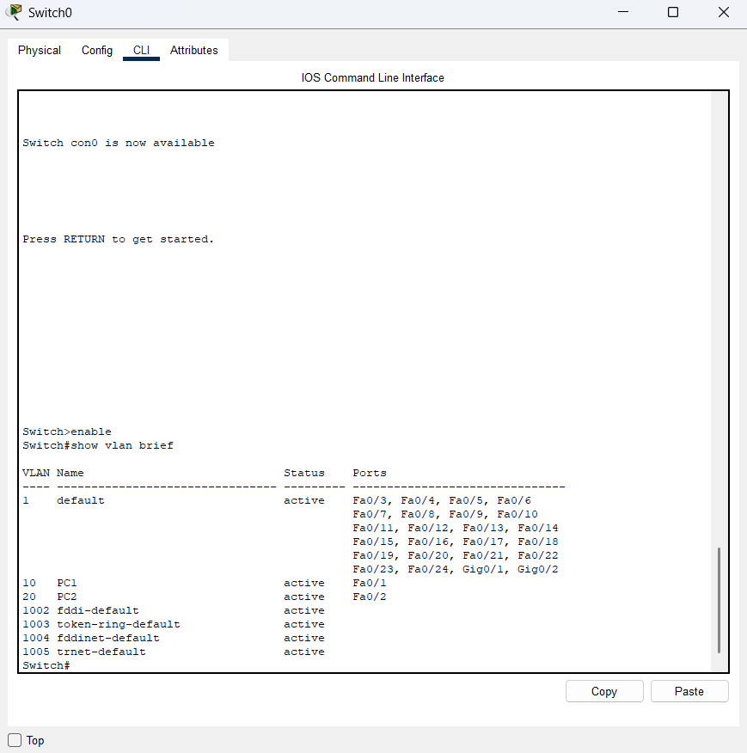

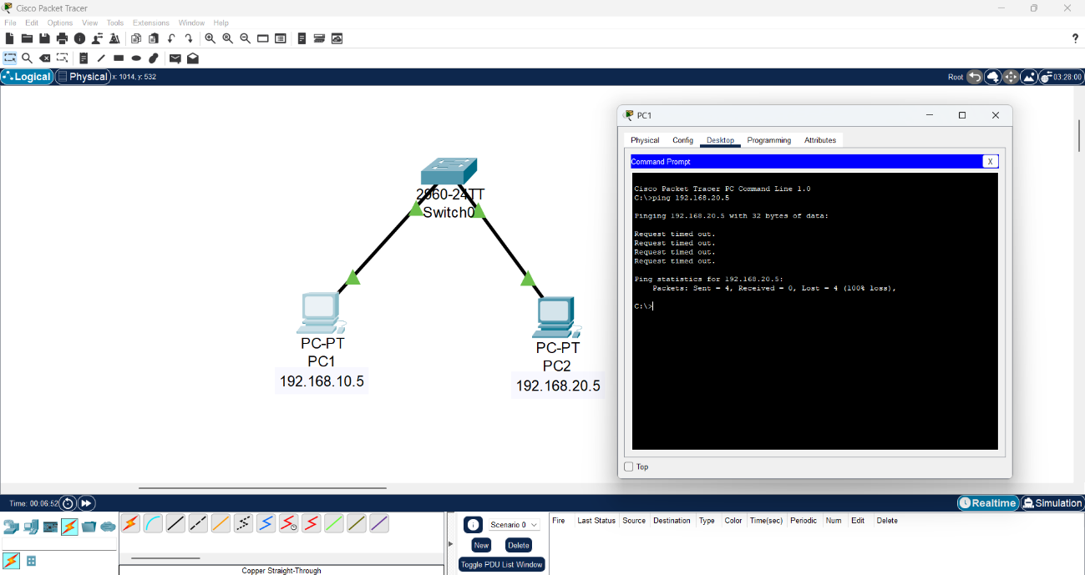

**The ping was unsuccessful.**

**When we configured the router in the network, the ping was successful:**

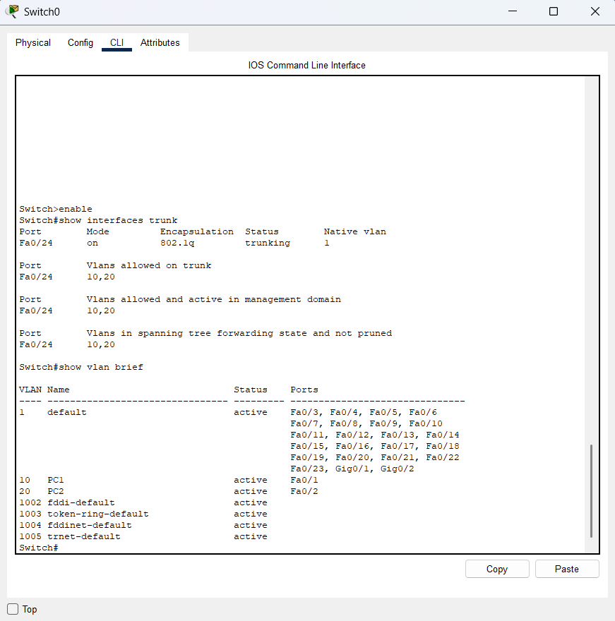

**The switch and router were configured according and also assigned the IP default gateways in the router.**

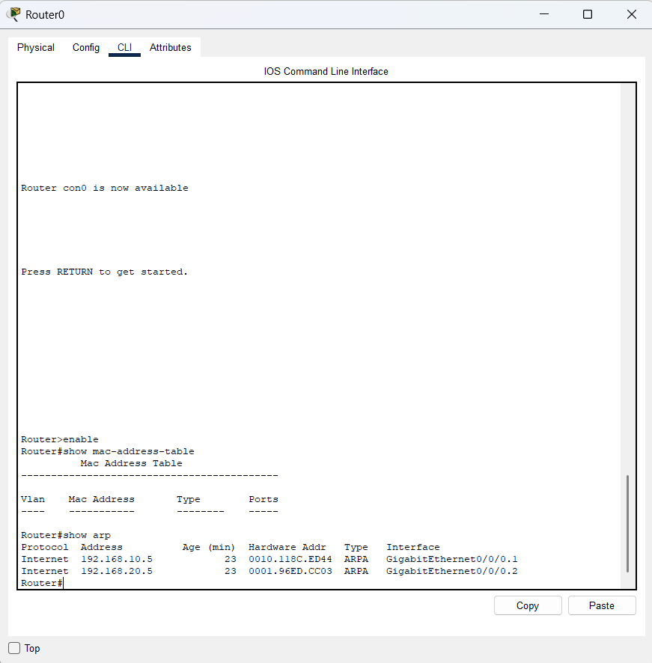

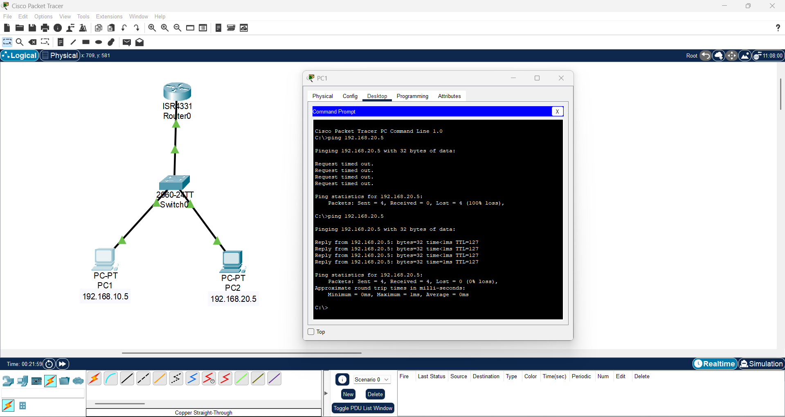

**The ICMP packet travels from the switch to the router and back and then reached the end PC1.**

